UNITED STATES
SECURITIES AND EXCHANGE COMMISSION
Washington, D.C. 20549

FORM 8-K

CURRENT REPORT
Pursuant to Section 13 or 15(d)
of the Securities Exchange Act of 1934
Date of Report (Date of earliest event reported): April 28, 2022


SS&C TECHNOLOGIES HOLDINGS, INC.
(Exact name of Registrant as Specified in Its Charter)

Delaware | 001-34675 | 71-0987913
(State or Other Jurisdiction  of Incorporation) | (Commission  File Number) | (IRS Employer  Identification No.)

80 Lamberton Road, Windsor, CT | 06095
(Address of Principal Executive Offices) | (Zip Code)
Registrant’s telephone number, including area code: (860) 298-4500
Not Applicable
(Former Name or Former Address, if Changed Since Last Report)

Check the appropriate box below if the Form 8-K filing is intended to simultaneously satisfy the filing obligation of the registrant under any of the following provisions (see General Instruction A.2. below):

☐ | Written communications pursuant to Rule 425 under the Securities Act (17 CFR 230.425)
☐ | Soliciting material pursuant to Rule 14a-12 under the Exchange Act (17 CFR 240.14a-12)
☐ | Pre-commencement communications pursuant to Rule 14d-2(b) under the Exchange Act (17 CFR 240.14d-2(b))
☐ | Pre-commencement communications pursuant to Rule 13e-4(c) under the Exchange Act (17 CFR 240.13e-4(c))
Indicate by check mark whether the registrant is an emerging growth company as defined in Rule 405 of the Securities Act of 1933 (§230.405 of this chapter) or Rule 12b-2 of the Securities Exchange Act of 1934 (§240.12b-2 of this chapter).
☐ | Emerging growth company
If an emerging growth company, indicate by check mark if the registrant has elected not to use the extended transition period for complying with any new or revised financial accounting standards provided pursuant to Section 13(a) of the Exchange Act. ☐
Securities registered pursuant to Section 12(b) of the Act:
Title of each class | Trading Symbol | Name of each exchange on which registered
Common stock, par value $0.01 per share | SSNC | The Nasdaq Global Select Market

Item 2.02. Results of Operations and Financial Condition
On April 28, 2022, SS&C Technologies Holdings, Inc. (the “Company”) announced its financial results for the quarter ended March 31, 2022. The full text of the press release and earnings release presentation issued in connection with the announcement are furnished as Exhibit 99.1 and Exhibit 99.2, respectively, to this Current Report on Form 8-K.‌
The information in this Form 8-K (including Exhibits 99.1 and 99.2) shall not be deemed “filed” for purposes of Section 18 of the Securities Exchange Act of 1934 (the “Exchange Act”) or otherwise subject to the liabilities of that section, nor shall it be deemed incorporated by reference in any filing under the Securities Act of 1933 or the Exchange Act, except as expressly set forth by specific reference in such a filing.
Item 9.01. Financial Statements and Exhibits
(d) Exhibits
The following exhibits relating to Item 2.02 shall be deemed to be furnished, and not filed:

99.1 | Press Release, issued by the Company on April 28, 2022.
99.2 | Q1 2022 Earnings Presentation dated April 28, 2022.
104 | The cover page from this Current Report on Form 8-K, formatted in Inline XBRL

SIGNATURE
Pursuant to the requirements of the Securities Exchange Act of 1934, the Registrant has duly caused this report to be signed on its behalf by the undersigned hereunto duly authorized.

 |  | SS&C TECHNOLOGIES HOLDINGS, INC.
Date: April 28, 2022 |  | By: | /s/ Patrick J. Pedonti
 |  |  | Patrick J. Pedonti
 |  |  | Senior Vice President and Chief Financial Officer

Exhibit 99.1
SS&C Technologies Releases Q1 2022 Earnings Results

Q1 2022 GAAP revenue $1,295.0 million, up 5.0%, Fully Diluted GAAP Earnings Per Share $0.64, down 1.5%
Adjusted revenue $1,296.2 million, up 4.9%, Adjusted Diluted Earnings Per Share $1.25, up 5.9%

WINDSOR, CT, April 28, 2022 (PR Newswire) SS&C Technologies Holdings, Inc. (NASDAQ: SSNC), a global provider of investment, financial and healthcare software-enabled services and software, today announced its financial results for the first quarter ended March 31, 2022.

 | Three Months Ended March 31,
(in millions, except per share data): | 2022 | 2021 | Change
GAAP Results
Revenue | $1,295.0 | $1,233.4 | 5.0%
Operating income | 291.8 | 269.1 | 8.4%
Operating income margin | 22.5% | 21.8% | 70 bp
Diluted earnings per share attributable to SS&C | $0.64 | $0.65 | (1.5)%
Adjusted Non-GAAP Results (defined in Notes 1 - 4 below)
Adjusted revenue | $1,296.2 | $1,235.4 | 4.9%
Adjusted operating income attributable to SS&C | 498.7 | 475.8 | 4.8%
Adjusted operating income margin | 38.5% | 38.5% | 0 bp
Adjusted diluted earnings per share attributable to SS&C | $1.25 | $1.18 | 5.9%

First Quarter 2022 Highlights:

•Q1 2022 organic growth was 4.3%, with strong performance from our Alternatives, Intralinks, and Advent business units.•Q1 2022 financial services organic growth, excluding the healthcare business, was 5.9%, which represents 93% of our revenues.•As expected, healthcare revenue declined 15.5% in Q1 2022. With our upcoming launch of DomaniRx, and the interest this new technology has generated, we expect a strong recovery in 2023.•SS&C generated net cash from operating activities of $183.5 million for the three months ended March 31, 2022.•Repurchased 2.3 million shares of common stock in Q1 2022 at an average price of $75.22 per share for $170.9 million.•SS&C reported adjusted consolidated EBITDA attributable to SS&C of $514.9 million for Q1 2022.•Completed the acquisitions of Blue Prism and Hubwise.•In March, SS&C launched GoCentral. This new, more modern fund administration platform amplifies our processing and technology efficiency and provides our clients with higher quality deliverables with increased transparency.

“The tumultuous geo-political landscape and subsequent volatile markets have created a difficult market for SS&C and our clients. SS&C persevered and delivered strong 4.9% adjusted revenue growth, and 5.9% adjusted diluted EPS growth,” says Bill Stone, Chairman and Chief Executive Officer. "We successfully closed the Blue Prism and Hubwise acquisitions in mid March, both of which will provide further automation and robust technology for our joint client base. We are already implementing Blue Prism's digital workforce across our businesses to accelerate automation efforts and increase efficiency. As expected, the interest expense and short term operating losses at Blue Prism will have a short term negative effect on earnings.”


1

Operating Cash Flow

SS&C generated net cash from operating activities of $183.5 million for the three months ended March 31, 2022, compared to $185.7 million for the same period in 2021, a 1.2% decrease. SS&C ended the first quarter with $558.1 million in cash and cash equivalents and $7,588.9 million in gross debt. SS&C’s net debt balance as defined in our credit agreement, which excludes cash and cash equivalents of $145.0 million held at DomaniRx, LLC was $7,175.8 million as of March 31, 2022. SS&C’s consolidated net leverage ratio as defined in our credit agreement stood at 3.48 times consolidated EBITDA attributable to SS&C as of March 31, 2022. SS&C’s net secured leverage ratio stood at 2.51 times consolidated EBITDA attributable to SS&C as of March 31, 2022.

Guidance
 |  | Q2 2022 |  | FY 2022
Adjusted Revenue ($M) |  | $1,328.0 – $1,368.0 |  | $5,350.0 – $5,510.0
Adjusted Net Income attributable to SS&C ($M) |  | $301.0 – $317.0 |  | $1,329.0 – $1,395.0
Adjusted Diluted Earnings per Share attributable to SS&C |  | $1.13 – $1.19 |  | $4.99 – $5.21
Cash from Operating Activities ($M) |  | – |  | $1,315.0 – $1,375.0
Capital Expenditures (% of revenue) |  | – |  | 2.6% – 3.0%
Diluted Shares (M) |  | 267.2 – 266.7 |  | 268.0 – 266.4
Effective Income Tax Rate (%) |  | 26% |  | 26%

SS&C does not provide reconciliations of guidance for Adjusted Revenues and Adjusted Net Income to comparable GAAP measures, in reliance on the unreasonable efforts exception provided under Item 10(e)(1)(i)(B) of Regulation S-K. SS&C is unable, without unreasonable efforts, to forecast certain items required to develop meaningful comparable GAAP financial measures. These items include acquisition transactions and integration, foreign exchange rate changes, as well as other non-cash and other adjustments as defined under the Company’s Credit agreement, that are difficult to predict in advance in order to include in a GAAP estimate. The unavailable information could have a significant impact on Q2 2022 and FY 2022 GAAP financial results.

Non-GAAP Financial Measures

Adjusted revenue, adjusted operating income, adjusted consolidated EBITDA, adjusted net income and adjusted diluted earnings per share are non-GAAP measures. See the accompanying notes for the reconciliations and definitions for each of these non-GAAP measures and the reasons our management believes these measures provide useful information to investors regarding our financial condition and results of operations.

2

Earnings Call and Press Release
SS&C’s Q1 2022 earnings call will take place at 5:00 p.m. eastern time today, April 28, 2022. The call will discuss Q1 2022 results and business outlook. Interested parties may dial 888-210-4650 (US and Canada) or 646-960-0327 (International), and request the “SS&C Technologies First Quarter 2022 Earnings Conference Call”; conference ID #4673675. In connection with the earnings call, a presentation will be available on SS&C’s website at http://investor.ssctech.com/results.cfm. A replay will be available after 8:00 p.m. eastern time on April 28, 2022, until midnight on May 5, 2022. The replay dial-in number is 800-770-2030 (US and Canada) or 647-362-9199 (International); access code #4673675. The call will also be available for replay on SS&C’s website after April 28, 2022; access: http://investor.ssctech.com/results.cfm.
Certain information contained in this press release relating to, among other things, the Company’s financial guidance for the second quarter and full year of 2022 constitute forward-looking statements for purposes of the safe harbor provisions under the Private Securities Litigation Reform Act of 1995. Forward-looking statements include statements concerning plans, objectives, goals, strategies, expectations, intentions, projections, developments, future events, performance, underlying assumptions, and other statements that are other than statements of historical facts. Without limiting the foregoing, the words “believes”, “anticipates”, “plans”, “expects”, “estimates”, “projects”, “forecasts”, “may”, “assume”, “intend”, “will”, “continue”, “opportunity”, “predict”, “potential”, “future”, “guarantee”, “likely”, “target”, “indicate”, “would”, “could” and “should” and similar expressions are intended to identify forward-looking statements, although not all forward-looking statements are accompanied by such words. Such statements reflect management’s best judgment based on factors currently known but are subject to risks and uncertainties, which could cause actual results to differ materially from those anticipated. Such risks and uncertainties include, but are not limited to, the state of the economy and the financial services industry and other industries in which the Company’s clients operate, the Company’s ability to realize anticipated benefits from its acquisitions, including DST Systems, Inc., the effect of customer consolidation on demand for the Company’s products and services, the increasing focus of the Company’s business on the hedge fund industry, the variability of revenue as a result of activity in the securities markets, the ability to retain and attract clients, fluctuations in customer demand for the Company’s products and services, the intensity of competition with respect to the Company’s products and services, the exposure to litigation and other claims, terrorist activities and other catastrophic events, disruptions, attacks or failures affecting the Company’s software-enabled services, risks associated with the Company’s foreign operations, privacy concerns relating to the collection and storage of personal information, evolving regulations and increased scrutiny from regulators, the Company’s ability to protect intellectual property assets and litigation regarding intellectual property rights, delays in product development, investment decisions concerning cash balances, regulatory and tax risks, risks associated with the Company’s joint ventures, changes in accounting standards, risks related to the Company’s substantial indebtedness, the market price of the Company’s stock prevailing from time to time, and the risks discussed in the “Risk Factors” section of the Company’s most recent Annual Report on Form 10-K and Quarterly Report on Form 10-Q, which are on file with the Securities and Exchange Commission and can also be accessed on our website. Forward-looking statements speak only as of the date on which they are made and, except to the extent required by applicable securities laws, we undertake no obligation to update or revise any forward-looking statements.

3

About SS&C Technologies
SS&C is a global provider of services and software for the financial services and healthcare industries. Founded in 1986, SS&C is headquartered in Windsor, Connecticut, and has offices around the world. Some 20,000 financial services and healthcare organizations, from the world's largest companies to small and mid-market firms, rely on SS&C for expertise, scale, and technology.
Follow SS&C on Twitter, LinkedIn and Facebook.
For more information
Patrick Pedonti
Chief Financial Officer
Tel: +1-860-298-4738
E-mail: InvestorRelations@sscinc.com

Justine Stone
Investor Relations
Tel: +1-212-367-4705
E-mail: InvestorRelations@sscinc.com

4

SS&C Technologies Holdings, Inc. and Subsidiaries
Condensed Consolidated Statements of Comprehensive Income
(in millions, except per share data)
(unaudited)

 |  | Three Months Ended March 31,
 |  | 2022 |  |  |  | 2021
Revenues:
Software-enabled services |  | $ | 1,085.2 |  |  | $ | 1,043.4
License, maintenance and related |  |  | 209.8 |  |  |  | 190.0
Total revenues |  |  | 1,295.0 |  |  |  | 1,233.4
Cost of revenues:
Software-enabled services |  |  | 595.5 |  |  |  | 595.5
License, maintenance and related |  |  | 79.7 |  |  |  | 78.8
Total cost of revenues |  |  | 675.2 |  |  |  | 674.3
Gross profit |  |  | 619.8 |  |  |  | 559.1
Operating expenses:
Selling and marketing |  |  | 110.9 |  |  |  | 92.0
Research and development |  |  | 105.8 |  |  |  | 107.9
General and administrative |  |  | 111.3 |  |  |  | 90.1
Total operating expenses |  |  | 328.0 |  |  |  | 290.0
Operating income |  |  | 291.8 |  |  |  | 269.1
Interest expense, net |  |  | (49.3 | ) |  |  | (51.4 | )
Other (expense) income, net |  |  | (9.0 | ) |  |  | 18.0
Equity in earnings of unconsolidated affiliates, net |  |  | 1.3 |  |  |  | 0.3
Loss on extinguishment of debt |  |  | — |  |  |  | (0.3 | )
Income before income taxes |  |  | 234.8 |  |  |  | 235.7
Provision for income taxes |  |  | 63.5 |  |  |  | 60.8
Net income |  |  | 171.3 |  |  |  | 174.9
Net loss attributable to noncontrolling interest |  |  | 0.8 |  |  |  | —
Net income attributable to SS&C common stockholders |  | $ | 172.1 |  |  | $ | 174.9
Basic earnings per share attributable to SS&C common stockholders |  | $ | 0.67 |  |  | $ | 0.68
Diluted earnings per share attributable to SS&C common stockholders |  | $ | 0.64 |  |  | $ | 0.65
Basic weighted-average number of common shares outstanding |  |  | 255.8 |  |  |  | 257.0
Diluted weighted-average number of common and common equivalent shares outstanding |  |  | 267.6 |  |  |  | 268.1
Net income |  | $ | 171.3 |  |  | $ | 174.9
Other comprehensive (loss) income, net of tax:
Change in unrealized gain on interest rate swaps |  |  | 1.2 |  |  |  | 0.5
Foreign currency exchange translation adjustment |  |  | (28.3 | ) |  |  | 8.4
Change in defined benefit pension obligation |  |  | (1.1 | ) |  |  | —
Total other comprehensive (loss) income, net of tax |  |  | (28.2 | ) |  |  | 8.9
Comprehensive income |  |  | 143.1 |  |  |  | 183.8
Comprehensive loss attributable to noncontrolling interest |  |  | 0.8 |  |  |  | —
Comprehensive income attributable to SS&C common stockholders |  | $ | 143.9 |  |  | $ | 183.8

5

SS&C Technologies Holdings, Inc. and Subsidiaries
Condensed Consolidated Balance Sheets
(in millions)
(unaudited)

 |  | March 31, |  |  |  | December 31,
 |  | 2022 |  |  |  | 2021
Assets
Current assets:
Cash and cash equivalents |  | $ | 558.1 |  |  | $ | 564.0
Funds receivable and funds held on behalf of clients |  |  | 2,549.6 |  |  |  | 2,755.7
Accounts receivable, net |  |  | 791.9 |  |  |  | 713.4
Contract asset |  |  | 32.5 |  |  |  | 27.4
Prepaid expenses and other current assets |  |  | 192.2 |  |  |  | 187.5
Restricted cash |  |  | 3.4 |  |  |  | 4.2
Total current assets |  |  | 4,127.7 |  |  |  | 4,252.2
Property, plant and equipment, net |  |  | 356.6 |  |  |  | 382.0
Operating lease right-of-use assets |  |  | 291.1 |  |  |  | 291.2
Investments |  |  | 173.6 |  |  |  | 172.8
Unconsolidated affiliates |  |  | 308.6 |  |  |  | 306.1
Contract asset |  |  | 80.2 |  |  |  | 77.9
Goodwill |  |  | 9,055.2 |  |  |  | 8,045.5
Intangible and other assets, net |  |  | 4,498.1 |  |  |  | 3,805.3
Total assets |  | $ | 18,891.1 |  |  | $ | 17,333.0
Liabilities, Redeemable Noncontrolling Interest and Stockholders’ Equity
Current liabilities:
Current portion of long-term debt |  | $ | 146.7 |  |  | $ | 47.4
Client funds obligations |  |  | 2,549.6 |  |  |  | 2,755.7
Accounts payable |  |  | 46.9 |  |  |  | 28.7
Income taxes payable |  |  | 50.3 |  |  |  | 25.5
Accrued employee compensation and benefits |  |  | 160.1 |  |  |  | 322.2
Interest payable |  |  | 1.1 |  |  |  | 27.5
Other accrued expenses |  |  | 364.0 |  |  |  | 310.1
Deferred revenue |  |  | 487.4 |  |  |  | 334.0
Total current liabilities |  |  | 3,806.1 |  |  |  | 3,851.1
Long-term debt, net of current portion |  |  | 7,373.7 |  |  |  | 5,901.5
Operating lease liabilities |  |  | 266.1 |  |  |  | 268.2
Other long-term liabilities |  |  | 261.5 |  |  |  | 254.0
Deferred income taxes |  |  | 940.1 |  |  |  | 835.0
Total liabilities |  |  | 12,647.5 |  |  |  | 11,109.8
Redeemable noncontrolling interest |  |  | 10.9 |  |  |  | —
SS&C stockholders' equity |  |  | 6,175.7 |  |  |  | 6,165.4
Noncontrolling interest |  |  | 57.0 |  |  |  | 57.8
Total stockholders’ equity |  |  | 6,232.7 |  |  |  | 6,223.2
Total liabilities, redeemable noncontrolling interest and stockholders’ equity |  | $ | 18,891.1 |  |  | $ | 17,333.0

6

SS&C Technologies Holdings, Inc. and Subsidiaries
Condensed Consolidated Statements of Cash Flows
(in millions)
(unaudited)

 |  | Three Months Ended March 31,
 |  | 2022 |  |  |  | 2021
Cash flow from operating activities:
Net income |  | $ | 171.3 |  |  | $ | 174.9
Adjustments to reconcile net income to net cash provided by operating activities:
Depreciation and amortization |  |  | 165.6 |  |  |  | 169.5
Equity in earnings of unconsolidated affiliates, net |  |  | (1.3 | ) |  |  | (0.3 | )
Gain on bargain purchase |  |  | — |  |  |  | (2.9 | )
Stock-based compensation expense |  |  | 39.9 |  |  |  | 27.8
Net losses (gains) on investments |  |  | 3.8 |  |  |  | (13.6 | )
Amortization and write-offs of loan origination costs and original issue discounts |  |  | 2.6 |  |  |  | 3.3
Loss on extinguishment of debt, net |  |  | — |  |  |  | 0.3
Deferred income taxes |  |  | (33.3 | ) |  |  | (33.5 | )
Provision for credit losses |  |  | 2.8 |  |  |  | 2.1
Changes in operating assets and liabilities, excluding effects from acquisitions:
Accounts receivable |  |  | (32.4 | ) |  |  | (24.9 | )
Prepaid expenses and other assets |  |  | 7.9 |  |  |  | (13.9 | )
Contract assets |  |  | (7.0 | ) |  |  | (6.5 | )
Accounts payable |  |  | 8.2 |  |  |  | (2.6 | )
Accrued expenses and other liabilities |  |  | (186.5 | ) |  |  | (147.7 | )
Income taxes prepaid and payable |  |  | 48.8 |  |  |  | 47.2
Deferred revenue |  |  | (6.9 | ) |  |  | 6.5
Net cash provided by operating activities |  |  | 183.5 |  |  |  | 185.7
Cash flow from investing activities:
Cash paid for business acquisitions, net of cash acquired |  |  | (1,553.1 | ) |  |  | 7.3
Additions to property and equipment |  |  | (10.8 | ) |  |  | (9.1 | )
Additions to capitalized software |  |  | (24.8 | ) |  |  | (22.3 | )
Investments in securities |  |  | — |  |  |  | (10.0 | )
Proceeds from sales / maturities of investments |  |  | 2.5 |  |  |  | 13.4
Collection of other non-current receivables |  |  | 2.7 |  |  |  | 2.8
Net cash used in investing activities |  |  | (1,583.5 | ) |  |  | (17.9 | )
Cash flow from financing activities:
Cash received from debt borrowings |  |  | 1,632.1 |  |  |  | 170.0
Repayments of debt |  |  | (48.2 | ) |  |  | (99.4 | )
Payment of deferred financing fees |  |  | (12.4 | ) |  |  | —
Net (decrease) increase in client funds obligations |  |  | (156.9 | ) |  |  | 777.0
Proceeds from exercise of stock options |  |  | 48.8 |  |  |  | 30.6
Withholding taxes paid related to equity award net share settlement |  |  | (0.5 | ) |  |  | (1.9 | )
Purchases of common stock for treasury |  |  | (170.9 | ) |  |  | (181.4 | )
Dividends paid on common stock |  |  | (51.1 | ) |  |  | (41.2 | )
Net cash provided by financing activities |  |  | 1,240.9 |  |  |  | 653.7
Effect of exchange rate changes on cash, cash equivalents and restricted cash |  |  | (4.5 | ) |  |  | (1.7 | )
Net (decrease) increase in cash, cash equivalents and restricted cash |  |  | (163.6 | ) |  |  | 819.8
Cash, cash equivalents and restricted cash, beginning of period |  |  | 3,171.4 |  |  |  | 1,337.9
Cash, cash equivalents and restricted cash and cash equivalents, end of period |  | $ | 3,007.8 |  |  | $ | 2,157.7
Reconciliation of cash, cash equivalents and restricted cash and cash equivalents:
Cash and cash equivalents |  | $ | 558.1 |  |  | $ | 253.7
Restricted cash and cash equivalents |  |  | 3.4 |  |  |  | 4.4
Restricted cash and cash equivalents included in funds receivable and funds held on behalf of clients |  |  | 2,446.3 |  |  |  | 1,899.6
 |  | $ | 3,007.8 |  |  | $ | 2,157.7

7

SS&C Technologies Holdings, Inc. and Subsidiaries
Disclosures Relating to Non-GAAP Financial Measures
Note 1. Reconciliation of Revenues to Adjusted Revenues
Adjusted revenues represents revenues adjusted to include a) amounts that would have been recognized if deferred revenue were not adjusted to fair value at the date of acquisition and b) amounts that would have been recognized if not for adjustments to deferred revenue and retained earnings related to the adoption of ASC 606. Adjusted revenues is presented because we use this measure to evaluate performance of our business against prior periods and believe it is a useful indicator of the underlying performance of our business. Adjusted revenues is not a recognized term under generally accepted accounting principles (“GAAP”). Adjusted revenues does not represent revenues, as that term is defined under GAAP, and should not be considered as an alternative to revenues as an indicator of our operating performance. Adjusted revenues as presented herein is not necessarily comparable to similarly titled measures presented by other companies. Below is a reconciliation of adjusted revenues to revenues, the GAAP measure we believe to be most directly comparable to adjusted revenues.

 |  | Three Months Ended March 31,
(in millions) |  | 2022 |  |  |  | 2021
Revenues |  | $ | 1,295.0 |  |  | $ | 1,233.4
ASC 606 adoption impact |  |  | (0.5 | ) |  |  | 0.1
Purchase accounting adjustments impact on revenue |  |  | 1.7 |  |  |  | 1.9
Adjusted revenues |  | $ | 1,296.2 |  |  | $ | 1,235.4

The following is a breakdown of software-enabled services and license, maintenance and related revenues and adjusted software-enabled services and license, maintenance and related revenues.

 |  | Three Months Ended March 31,
(in millions) |  | 2022 |  |  |  | 2021
Software-enabled services |  | $ | 1,085.2 |  |  | $ | 1,043.4
License, maintenance and related |  |  | 209.8 |  |  |  | 190.0
Total revenues |  | $ | 1,295.0 |  |  | $ | 1,233.4
Software-enabled services |  | $ | 1,086.5 |  |  | $ | 1,045.2
License, maintenance and related |  |  | 209.7 |  |  |  | 190.2
Total adjusted revenues |  | $ | 1,296.2 |  |  | $ | 1,235.4

Note 2. Reconciliation of Operating Income to Adjusted Operating Income
Adjusted operating income represents operating income adjusted for amortization of intangible assets, stock-based compensation, purchase accounting adjustments for deferred revenue and related costs, ASC 606 adoption impact and other expenses. Adjusted operating income is presented because we use this measure to evaluate performance of our business and believe it is a useful indicator of our underlying performance. Adjusted operating income is not a recognized term under GAAP. Adjusted operating income does not represent operating income, as that term is defined under GAAP, and should not be considered as an alternative to operating income as an indicator of our operating performance. Adjusted operating income as presented herein is not necessarily comparable to similarly titled measures by other companies. The following is a reconciliation between adjusted operating income and operating income, the GAAP measure we believe to be most directly comparable to adjusted operating income.

 |  | Three Months Ended March 31,
(in millions) |  | 2022 |  |  |  | 2021
Operating income |  | $ | 291.8 |  |  | $ | 269.1
Amortization of intangible assets |  |  | 146.4 |  |  |  | 144.6
Stock-based compensation |  |  | 39.9 |  |  |  | 27.8
Purchase accounting adjustments (1) |  |  | 5.2 |  |  |  | 10.2
ASC 606 adoption impact |  |  | (0.4 | ) |  |  | 0.2
Other (2) |  |  | 15.7 |  |  |  | 23.9
Adjusted operating income |  | $ | 498.6 |  |  | $ | 475.8
Adjusted operating loss attributable to noncontrolling interest (3) |  |  | 0.1 |  |  |  | —
Adjusted operating income attributable to SS&C common stockholders |  | $ | 498.7 |  |  | $ | 475.8

(1)Purchase accounting adjustments include (a) an adjustment to increase revenues by the amount that would have been recognized if deferred revenue were not adjusted to fair value at the date of acquisition, (b) an adjustment to increase personnel and commissions expense by the amount that would have been recognized if prepaid commissions and deferred personnel costs were not adjusted to fair value at the date of the acquisitions and (c) an adjustment to decrease depreciation expense by the amount that would not have been recognized if property, plant and equipment were not adjusted to fair value at the date of acquisition.
8

(2)Other includes expenses and income that are permitted to be excluded per the terms of our Credit Agreement from Consolidated EBITDA, a financial measure used in calculating our covenant compliance. These include expenses and income related to foreign currency transactions, facilities and workforce restructuring, legal settlements and business acquisitions.(3)On July 15, 2021, we entered into a joint venture named DomaniRx, LLC in which we are the majority interest holder and primary beneficiary. As such, we consolidate DomaniRx, LLC as a variable interest entity. Adjusted operating income attributable to noncontrolling interest represents adjusted operating income based on the ownership interest retained by the respective noncontrolling parties.

Note 3. Reconciliation of Net Income to EBITDA, Consolidated EBITDA and Adjusted Consolidated EBITDA
EBITDA represents net income before interest expense, income taxes, depreciation and amortization. Consolidated EBITDA, defined under our Credit Agreement entered into in April 2018, as amended, is used in calculating covenant compliance, and is EBITDA adjusted for certain items. Consolidated EBITDA is calculated by subtracting from or adding to EBITDA items of income or expense described below. Adjusted Consolidated EBITDA is calculated by subtracting acquired EBITDA (as defined below) from Consolidated EBITDA. EBITDA, Consolidated EBITDA and Adjusted Consolidated EBITDA are presented because we use these measures to evaluate performance of our business and believe them to be useful indicators of an entity’s debt capacity and its ability to service debt. EBITDA, Consolidated EBITDA and Adjusted Consolidated EBITDA are not recognized terms under GAAP and should not be considered in isolation or as alternatives to operating income, net income or cash flows from operating activities as indicators of our operating performance. These measures are not necessarily comparable to similarly titled measures by other companies. The following is a reconciliation of EBITDA, Consolidated EBITDA and Adjusted Consolidated EBITDA to net income.

 |  | Three Months Ended March 31, |  |  |  |  |  |  |  | Twelve Months Ended March 31,
(in millions) |  | 2022 |  |  |  | 2021 |  |  |  | 2022
Net income |  | $ | 171.3 |  |  | $ | 174.9 |  |  | $ | 797.0
Interest expense, net |  |  | 49.3 |  |  |  | 51.4 |  |  |  | 199.5
Provision for income taxes |  |  | 63.5 |  |  |  | 60.8 |  |  |  | 239.1
Depreciation and amortization |  |  | 165.6 |  |  |  | 169.5 |  |  |  | 663.6
EBITDA |  |  | 449.7 |  |  |  | 456.6 |  |  |  | 1,899.2
Stock-based compensation |  |  | 39.9 |  |  |  | 27.8 |  |  |  | 126.1
Acquired EBITDA and cost savings (1) |  |  | (6.4 | ) |  |  | 1.3 |  |  |  | (24.3 | )
Non-cash portion of straight-line rent expense |  |  | (0.6 | ) |  |  | (0.2 | ) |  |  | (2.3 | )
Loss on extinguishment of debt |  |  | — |  |  |  | 0.3 |  |  |  | 10.6
Equity in earnings of unconsolidated affiliates, net |  |  | (1.3 | ) |  |  | (0.3 | ) |  |  | (26.4 | )
Purchase accounting adjustments (2) |  |  | 2.9 |  |  |  | 1.6 |  |  |  | 7.6
ASC 606 adoption impact |  |  | (0.4 | ) |  |  | 0.2 |  |  |  | 0.4
Other (3) |  |  | 24.6 |  |  |  | 5.9 |  |  |  | 74.5
Consolidated EBITDA |  | $ | 508.4 |  |  | $ | 493.2 |  |  | $ | 2,065.4
Acquired EBITDA and cost savings (1) |  |  | 6.4 |  |  |  | (1.3 | ) |  |  | 24.3
Adjusted Consolidated EBITDA |  | $ | 514.8 |  |  | $ | 491.9 |  |  | $ | 2,089.7
Adjusted Consolidated EBITDA attributable to noncontrolling interest (4) |  |  | 0.1 |  |  |  | — |  |  |  | (1.9 | )
Adjusted Consolidated EBITDA attributable to SS&C common stockholders |  | $ | 514.9 |  |  | $ | 491.9 |  |  | $ | 2,087.8

(1)Acquired EBITDA reflects the EBITDA impact of significant businesses that were acquired during the period as if the acquisition occurred at the beginning of the period, as well as cost savings enacted in connection with acquisitions.(2)Purchase accounting adjustments include (a) an adjustment to increase revenues by the amount that would have been recognized if deferred revenue were not adjusted to fair value at the date of acquisitions (b) an adjustment to increase personnel and commissions expense by the amount that would have been recognized if prepaid commissions and deferred personnel costs were not adjusted to fair value at the date of the acquisitions and (c) an adjustment to increase or decrease rent expense by the amount that would have been recognized if lease obligations were not adjusted to fair value at the date of acquisitions.(3)Other includes expenses and income that are permitted to be excluded per the terms of our Credit Agreement from Consolidated EBITDA, a financial measure used in calculating our covenant compliance. These include expenses and income related to foreign currency transactions, investment gains and losses, facilities and workforce restructuring, legal settlements, business combinations and other items.(4)On July 15, 2021, we entered into a joint venture named DomaniRx, LLC in which we are the majority interest holder and primary beneficiary. As such, we consolidate DomaniRx, LLC as a variable interest entity. Adjusted Consolidated EBITDA attributable to noncontrolling interest represents adjusted Consolidated EBITDA based on the ownership interest retained by the respective noncontrolling parties.
9

Note 4. Reconciliation of Net Income to Adjusted Net Income and Diluted Earnings Per Share Attributable to SS&C to Adjusted Diluted Earnings Per Share Attributable to SS&C
Adjusted net income and adjusted diluted earnings per share attributable to SS&C represent net income and earnings per share attributable to SS&C before amortization of intangible assets and deferred financing costs, stock-based compensation, purchase accounting adjustments and other items. We consider adjusted net income and adjusted diluted earnings per share attributable to SS&C to be important to management and investors because they represent our operational performance exclusive of the effects of amortization of intangible assets and deferred financing costs, stock-based compensation, purchase accounting adjustments, loss on extinguishment of debt and other items, that are not operational in nature or comparable to those of our competitors. Adjusted net income and adjusted diluted earnings per share are not recognized terms under GAAP. Adjusted net income and adjusted diluted earnings per share do not represent net income or diluted earnings per share, as those terms are defined under GAAP, and should not be considered as alternatives to net income or diluted earnings per share as indicators of our operating performance. Adjusted net income and adjusted diluted earnings per share attributable to SS&C as presented herein are not necessarily comparable to similarly titled measures presented by other companies. Below is a reconciliation of adjusted net income and adjusted diluted earnings per share attributable to SS&C to net income and diluted earnings per share attributable to SS&C, the GAAP measures we believe to be most directly comparable to adjusted net income and adjusted diluted earnings per share.

 |  | Three Months Ended March 31,
(in millions, except per share data) |  | 2022 |  |  |  | 2021
GAAP – Net income |  | $ | 171.3 |  |  | $ | 174.9
Amortization of intangible assets |  |  | 146.4 |  |  |  | 144.6
Amortization of deferred financing costs and original issue discount |  |  | 2.6 |  |  |  | 3.3
Stock-based compensation |  |  | 39.9 |  |  |  | 27.8
Loss on extinguishment of debt |  |  | — |  |  |  | 0.3
Purchase accounting adjustments (1) |  |  | 5.2 |  |  |  | 10.2
ASC 606 adoption impact |  |  | (0.4 | ) |  |  | 0.2
Equity in earnings of unconsolidated affiliates, net |  |  | (1.3 | ) |  |  | (0.3 | )
Other (2) |  |  | 24.6 |  |  |  | 5.9
Income tax effect (3) |  |  | (54.0 | ) |  |  | (50.4 | )
Adjusted net income |  | $ | 334.3 |  |  | $ | 316.5
Adjusted net loss attributable to noncontrolling interest (4) |  |  | 0.1 |  |  |  | —
Adjusted net income attributable to SS&C common stockholders |  | $ | 334.4 |  |  | $ | 316.5
Adjusted diluted earnings per share attributable to SS&C common stockholders |  | $ | 1.25 |  |  | $ | 1.18
GAAP diluted earnings per share attributable to SS&C common stockholders |  | $ | 0.64 |  |  | $ | 0.65
Diluted weighted-average shares outstanding |  |  | 267.6 |  |  |  | 268.1

(1)Purchase accounting adjustments include (a) an adjustment to increase revenues by the amount that would have been recognized if deferred revenue were not adjusted to fair value at the date of acquisition, (b) an adjustment to increase personnel and commissions expense by the amount that would have been recognized if prepaid commissions and deferred personnel costs were not adjusted to fair value at the date of the acquisitions and (c) an adjustment to decrease depreciation expense by the amount that would not have been recognized if property, plant and equipment were not adjusted to fair value at the date of acquisition.(2)Other includes expenses and income that are permitted to be excluded per the terms of our Credit Agreement from Consolidated EBITDA, a financial measure used in calculating our covenant compliance. These include expenses and income related to foreign currency transactions, investment gains and losses, facilities and workforce restructuring, legal settlements, business acquisitions and other items.(3)An estimated normalized effective tax rate of approximately 26% for the three months ended March 31, 2022 has been used to adjust the provision for income taxes for the purpose of computing adjusted net income.(4)On July 15, 2021, we entered into a joint venture named DomaniRx, LLC in which we are the majority interest holder and primary beneficiary. As such, we consolidate DomaniRx, LLC as a variable interest entity. Adjusted net income attributable to noncontrolling interest represents adjusted net income based on the ownership interest retained by the respective noncontrolling parties.

10

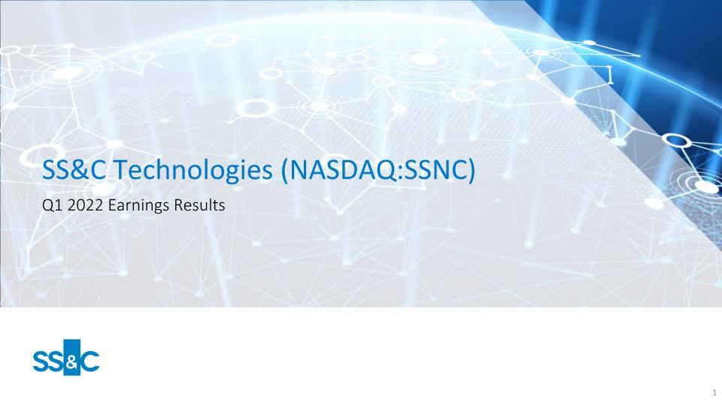
SS&C Technologies (NASDAQ:SSNC) Q1 2022 Earnings Results

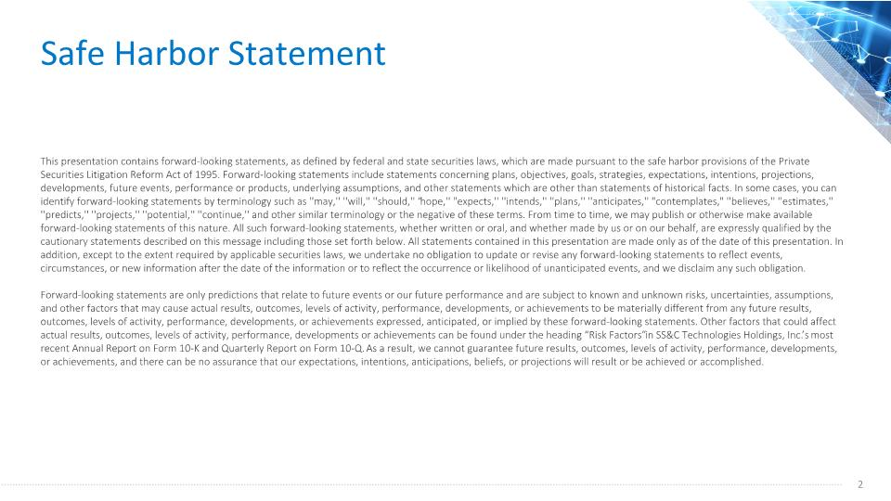
Safe Harbor Statement This presentation contains forward-looking statements, as defined by federal and state securities laws, which are made pursuant to the safe harbor provisions of the Private Securities Litigation Reform Act of 1995. Forward-looking statements include statements concerning plans, objectives, goals, strategies, expectations, intentions, projections, developments, future events, performance or products, underlying assumptions, and other statements which are other than statements of historical facts. In some cases, you can identify forward-looking statements by terminology such as ''may,'' ''will,'' ''should,'' “hope,'' "expects,'' ''intends,'' ''plans,'' ''anticipates,'' "contemplates," ''believes,'' ''estimates,'' ''predicts,'' ''projects,'' ''potential,'' ''continue,'' and other similar terminology or the negative of these terms. From time to time, we may publish or otherwise make available forward-looking statements of this nature. All such forward-looking statements, whether written or oral, and whether made by us or on our behalf, are expressly qualified by the cautionary statements described on this message including those set forth below. All statements contained in this presentation are made only as of the date of this presentation. In addition, except to the extent required by applicable securities laws, we undertake no obligation to update or revise any forward-looking statements to reflect events, circumstances, or new information after the date of the information or to reflect the occurrence or likelihood of unanticipated events, and we disclaim any such obligation. Forward-looking statements are only predictions that relate to future events or our future performance and are subject to known and unknown risks, uncertainties, assumptions, and other factors that may cause actual results, outcomes, levels of activity, performance, developments, or achievements to be materially different from any future results, outcomes, levels of activity, performance, developments, or achievements expressed, anticipated, or implied by these forward-looking statements. Other factors that could affect actual results, outcomes, levels of activity, performance, developments or achievements can be found under the heading “Risk Factors” in SS&C Technologies Holdings, Inc.’s most recent Annual Report on Form 10-K and Quarterly Report on Form 10-Q. As a result, we cannot guarantee future results, outcomes, levels of activity, performance, developments, or achievements, and there can be no assurance that our expectations, intentions, anticipations, beliefs, or projections will result or be achieved or accomplished.

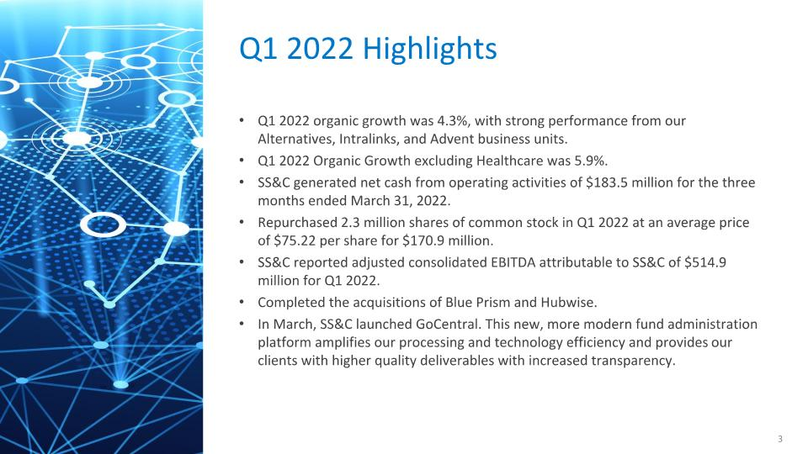
Q1 2022 organic growth was 4.3%, with strong performance from our Alternatives, Intralinks, and Advent business units. Q1 2022 Organic Growth excluding Healthcare was 5.9%. SS&C generated net cash from operating activities of $183.5 million for the three months ended March 31, 2022. Repurchased 2.3 million shares of common stock in Q1 2022 at an average price of $75.22 per share for $170.9 million. SS&C reported adjusted consolidated EBITDA attributable to SS&C of $514.9 million for Q1 2022. Completed the acquisitions of Blue Prism and Hubwise. In March, SS&C launched GoCentral. This new, more modern fund administration platform amplifies our processing and technology efficiency and provides our clients with higher quality deliverables with increased transparency. Q1 2022 Highlights

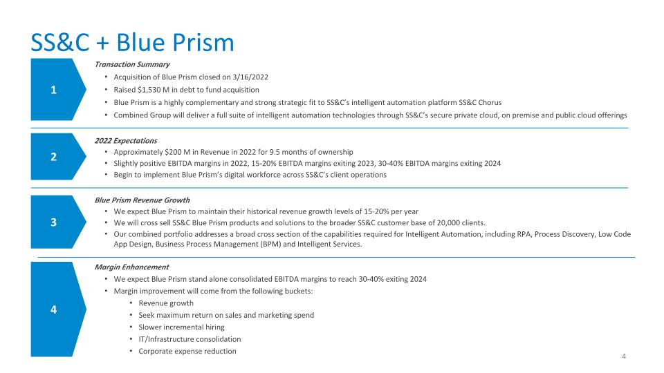
SS&C + Blue Prism Blue Prism Revenue Growth We expect Blue Prism to maintain their historical revenue growth levels of 15-20% per year We will cross sell SS&C Blue Prism products and solutions to the broader SS&C customer base of 20,000 clients. Our combined portfolio addresses a broad cross section of the capabilities required for Intelligent Automation, including RPA, Process Discovery, Low Code App Design, Business Process Management (BPM) and Intelligent Services. 1 4 3 Transaction Summary Acquisition of Blue Prism closed on 3/16/2022 Raised $1,530 M in debt to fund acquisition Blue Prism is a highly complementary and strong strategic fit to SS&C’s intelligent automation platform SS&C Chorus Combined Group will deliver a full suite of intelligent automation technologies through SS&C’s secure private cloud, on premise and public cloud offerings Margin Enhancement We expect Blue Prism stand alone consolidated EBITDA margins to reach 30-40% exiting 2024 Margin improvement will come from the following buckets: Revenue growth Seek maximum return on sales and marketing spend Slower incremental hiring IT/Infrastructure consolidation Corporate expense reduction 2022 Expectations Approximately $200 M in Revenue in 2022 for 9.5 months of ownership Slightly positive EBITDA margins in 2022, 15-20% EBITDA margins exiting 2023, 30-40% EBITDA margins exiting 2024 Begin to implement Blue Prism’s digital workforce across SS&C’s client operations 2

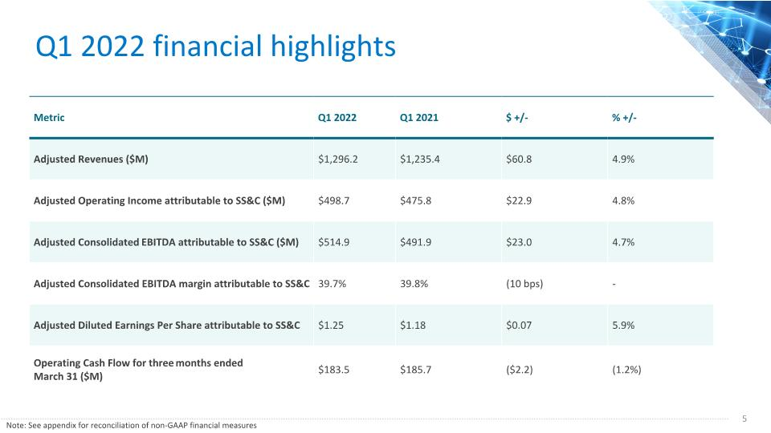
Q1 2022 financial highlights Metric Q1 2022 Q1 2021 $ +/- % +/- Adjusted Revenues ($M) $1,296.2 $1,235.4 $60.8 4.9% Adjusted Operating Income attributable to SS&C ($M) $498.7 $475.8 $22.9 4.8% Adjusted Consolidated EBITDA attributable to SS&C ($M) $514.9 $491.9 $23.0 4.7% Adjusted Consolidated EBITDA margin attributable to SS&C 39.7% 39.8% (10 bps) - Adjusted Diluted Earnings Per Share attributable to SS&C $1.25 $1.18 $0.07 5.9% Operating Cash Flow for three months ended March 31 ($M) $183.5 $185.7 ($2.2) (1.2%) Note: See appendix for reconciliation of non-GAAP financial measures

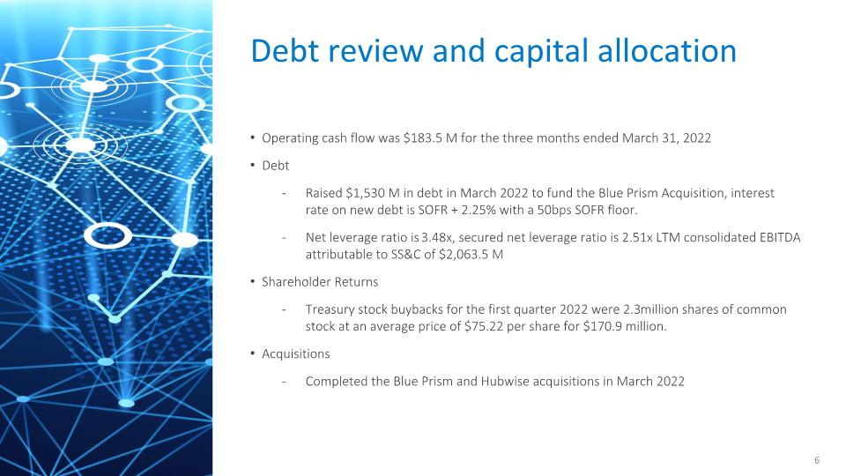
Operating cash flow was $183.5 M for the three months ended March 31, 2022 Debt Raised $1,530 M in debt in March 2022 to fund the Blue Prism Acquisition, interest rate on new debt is SOFR + 2.25% with a 50bps SOFR floor. Net leverage ratio is 3.48x, secured net leverage ratio is 2.51x LTM consolidated EBITDA attributable to SS&C of $2,063.5 M Shareholder Returns Treasury stock buybacks for the first quarter 2022 were 2.3 million shares of common stock at an average price of $75.22 per share for $170.9 million. Acquisitions Completed the Blue Prism and Hubwise acquisitions in March 2022 Debt review and capital allocation

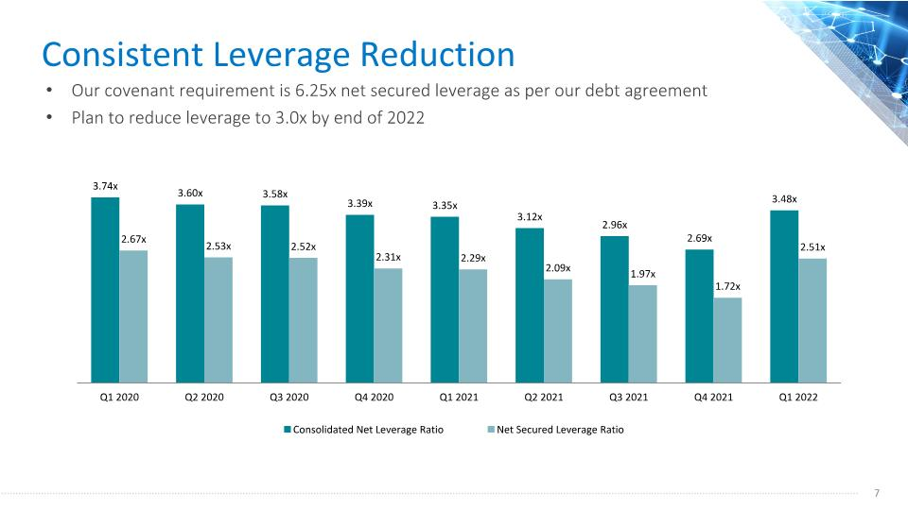
Consistent Leverage Reduction Our covenant requirement is 6.25x net secured leverage as per our debt agreement Plan to reduce leverage to 3.0x by end of 2022

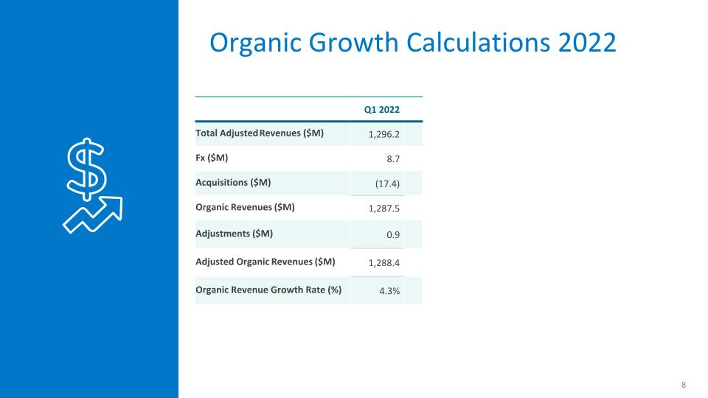
Organic Growth Calculations 2022 Q1 2022 Total Adjusted Revenues ($M) 1,296.2 Fx ($M) 8.7 Acquisitions ($M) (17.4) Organic Revenues ($M) 1,287.5 Adjustments ($M) 0.9 Adjusted Organic Revenues ($M) 1,288.4 Organic Revenue Growth Rate (%) 4.3%

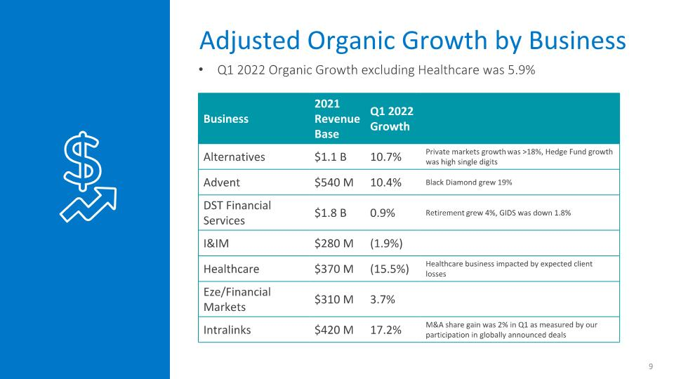
Adjusted Organic Growth by Business Business 2021 Revenue Base Q1 2022 Growth Alternatives $1.1 B 10.7% Private markets growth was >18%, Hedge Fund growth was high single digits Advent $540 M 10.4% Black Diamond grew 19% DST Financial Services $1.8 B 0.9% Retirement grew 4%, GIDS was down 1.8% I&IM $280 M (1.9%) Healthcare $370 M (15.5%) Healthcare business impacted by expected client losses Eze/Financial Markets $310 M 3.7% Intralinks $420 M 17.2% M&A share gain was 2% in Q1 as measured by our participation in globally announced deals Q1 2022 Organic Growth excluding Healthcare was 5.9%

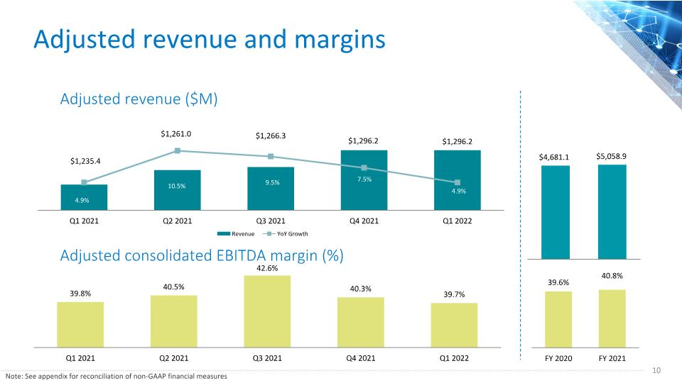
Adjusted revenue and margins Adjusted revenue ($M) Adjusted consolidated EBITDA margin (%) Note: See appendix for reconciliation of non-GAAP financial measures

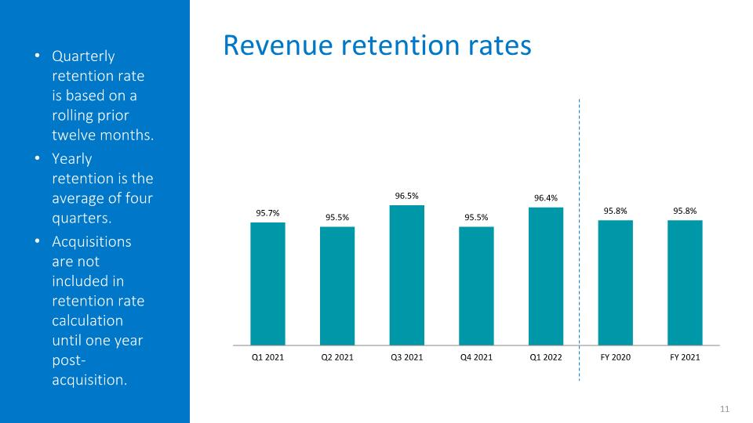
Quarterly retention rate is based on a rolling prior twelve months. Yearly retention is the average of four quarters. Acquisitions are not included in retention rate calculation until one year post-acquisition. Revenue retention rates

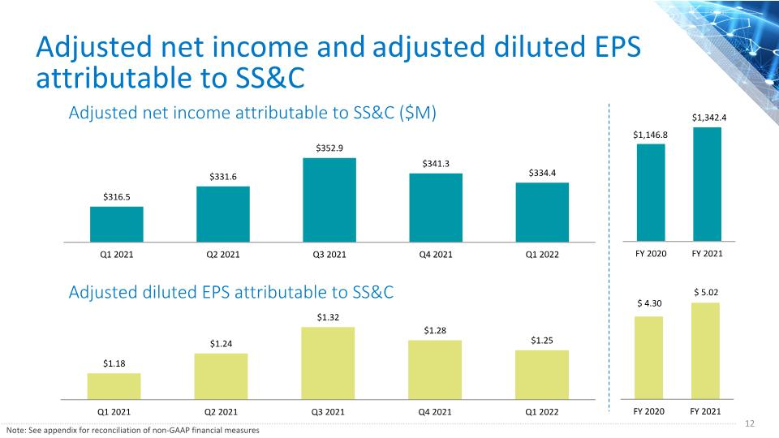
Adjusted net income and adjusted diluted EPS attributable to SS&C Adjusted net income attributable to SS&C ($M) Adjusted diluted EPS attributable to SS&C Note: See appendix for reconciliation of non-GAAP financial measures

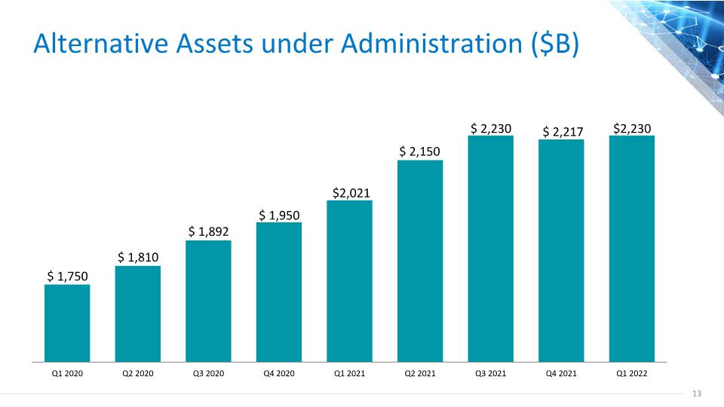
Alternative Assets under Administration ($B)

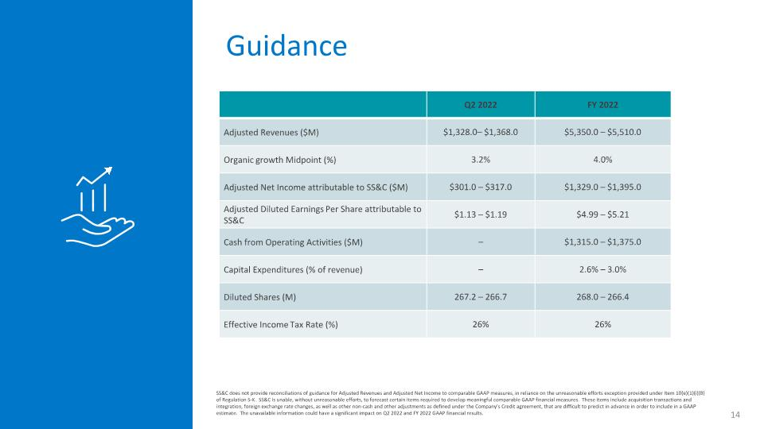
Guidance SS&C does not provide reconciliations of guidance for Adjusted Revenues and Adjusted Net Income to comparable GAAP measures, in reliance on the unreasonable efforts exception provided under Item 10(e)(1)(i)(B) of Regulation S-K. SS&C is unable, without unreasonable efforts, to forecast certain items required to develop meaningful comparable GAAP financial measures. These items include acquisition transactions and integration, foreign exchange rate changes, as well as other non-cash and other adjustments as defined under the Company’s Credit agreement, that are difficult to predict in advance in order to include in a GAAP estimate. The unavailable information could have a significant impact on Q2 2022 and FY 2022 GAAP financial results. Q2 2022 FY 2022 Adjusted Revenues ($M) $1,328.0– $1,368.0 $5,350.0 – $5,510.0 Organic growth Midpoint (%) 3.2% 4.0% Adjusted Net Income attributable to SS&C ($M) $301.0 – $317.0 $1,329.0 – $1,395.0 Adjusted Diluted Earnings Per Share attributable to SS&C $1.13 – $1.19 $4.99 – $5.21 Cash from Operating Activities ($M) – $1,315.0 – $1,375.0 Capital Expenditures (% of revenue) – 2.6% – 3.0% Diluted Shares (M) 267.2 – 266.7 268.0 – 266.4 Effective Income Tax Rate (%) 26% 26%

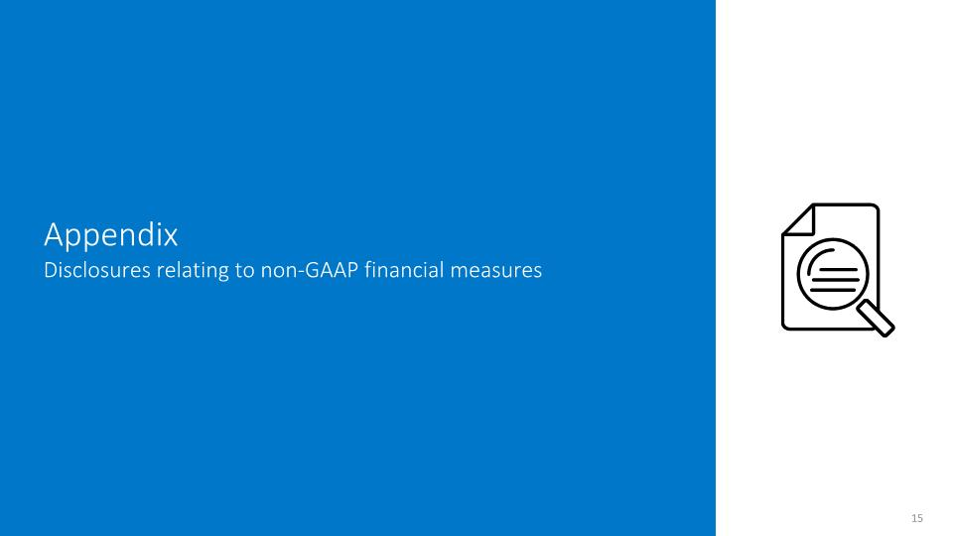
Appendix Disclosures relating to non-GAAP financial measures

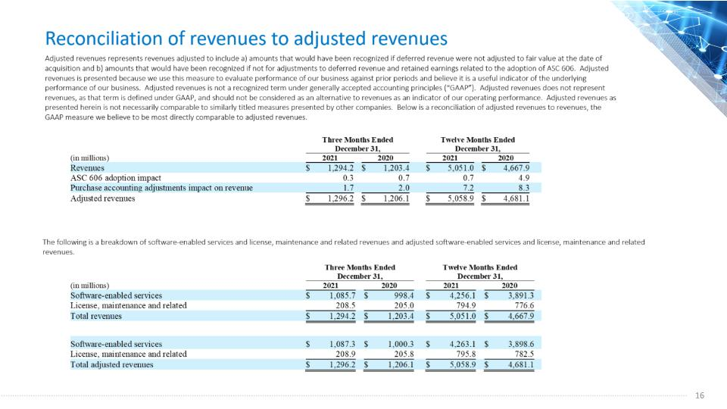

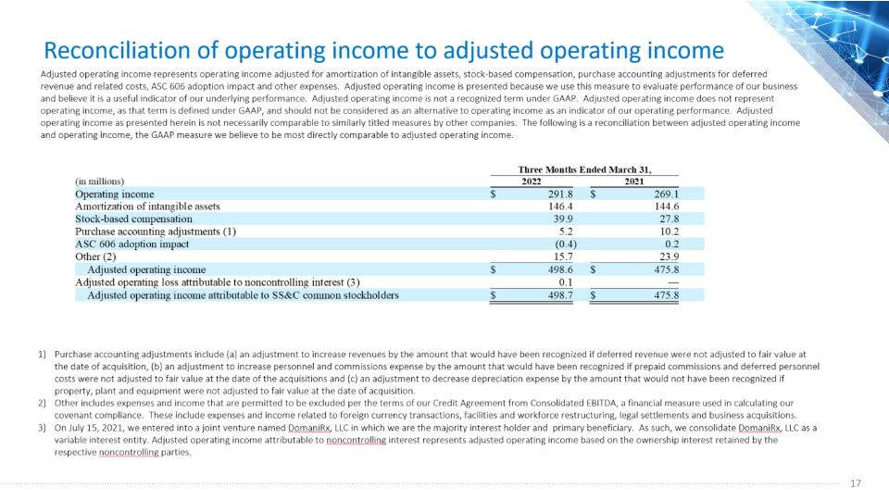

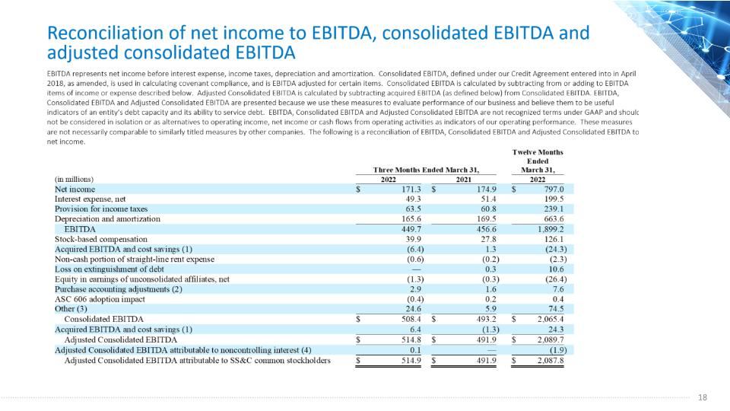

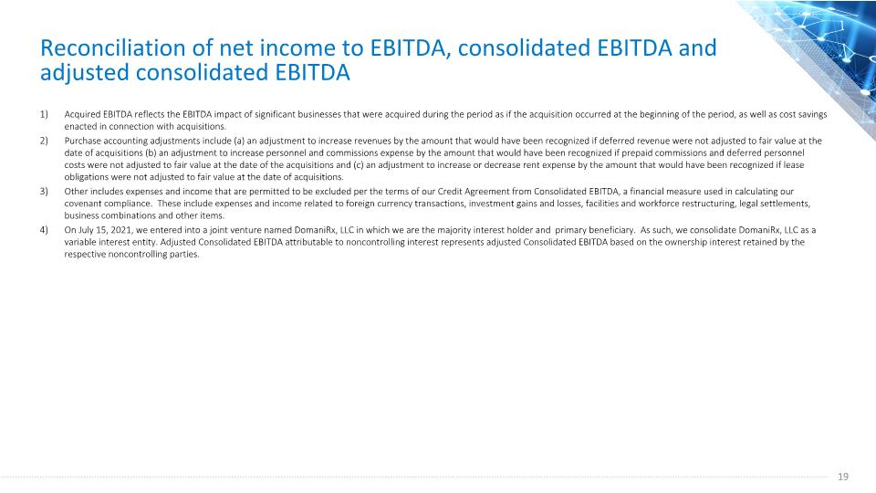
Reconciliation of net income to EBITDA, consolidated EBITDA and adjusted consolidated EBITDA Acquired EBITDA reflects the EBITDA impact of significant businesses that were acquired during the period as if the acquisition occurred at the beginning of the period, as well as cost savings enacted in connection with acquisitions. Purchase accounting adjustments include (a) an adjustment to increase revenues by the amount that would have been recognized if deferred revenue were not adjusted to fair value at the date of acquisitions (b) an adjustment to increase personnel and commissions expense by the amount that would have been recognized if prepaid commissions and deferred personnel costs were not adjusted to fair value at the date of the acquisitions and (c) an adjustment to increase or decrease rent expense by the amount that would have been recognized if lease obligations were not adjusted to fair value at the date of acquisitions. Other includes expenses and income that are permitted to be excluded per the terms of our Credit Agreement from Consolidated EBITDA, a financial measure used in calculating our covenant compliance. These include expenses and income related to foreign currency transactions, investment gains and losses, facilities and workforce restructuring, legal settlements, business combinations and other items. On July 15, 2021, we entered into a joint venture named DomaniRx, LLC in which we are the majority interest holder and primary beneficiary. As such, we consolidate DomaniRx, LLC as a variable interest entity. Adjusted Consolidated EBITDA attributable to noncontrolling interest represents adjusted Consolidated EBITDA based on the ownership interest retained by the respective noncontrolling parties.

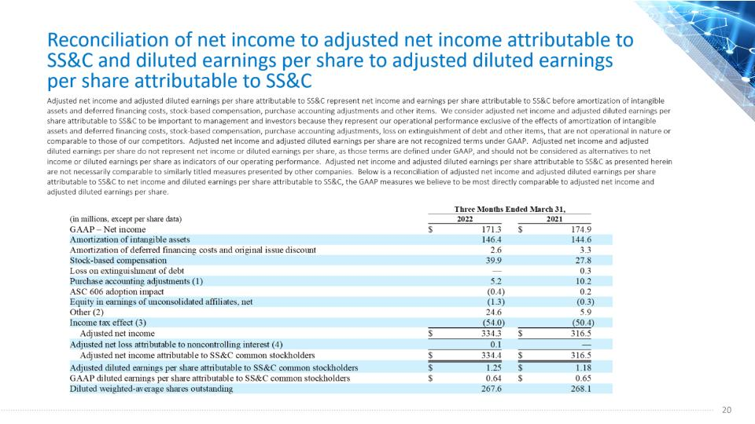

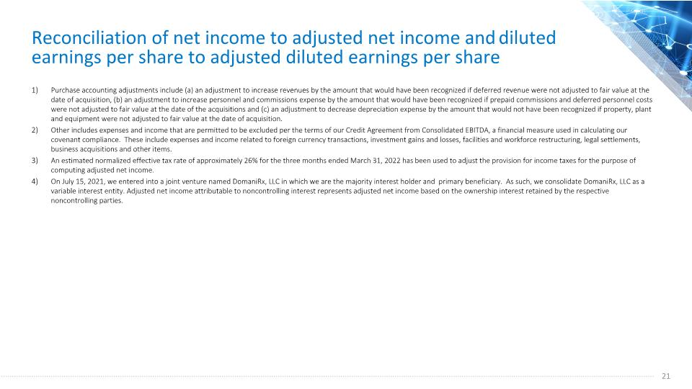
Reconciliation of net income to adjusted net income and diluted earnings per share to adjusted diluted earnings per share Purchase accounting adjustments include (a) an adjustment to increase revenues by the amount that would have been recognized if deferred revenue were not adjusted to fair value at the date of acquisition, (b) an adjustment to increase personnel and commissions expense by the amount that would have been recognized if prepaid commissions and deferred personnel costs were not adjusted to fair value at the date of the acquisitions and (c) an adjustment to decrease depreciation expense by the amount that would not have been recognized if property, plant and equipment were not adjusted to fair value at the date of acquisition. Other includes expenses and income that are permitted to be excluded per the terms of our Credit Agreement from Consolidated EBITDA, a financial measure used in calculating our covenant compliance. These include expenses and income related to foreign currency transactions, investment gains and losses, facilities and workforce restructuring, legal settlements, business acquisitions and other items. An estimated normalized effective tax rate of approximately 26% for the three months ended March 31, 2022 has been used to adjust the provision for income taxes for the purpose of computing adjusted net income. On July 15, 2021, we entered into a joint venture named DomaniRx, LLC in which we are the majority interest holder and primary beneficiary. As such, we consolidate DomaniRx, LLC as a variable interest entity. Adjusted net income attributable to noncontrolling interest represents adjusted net income based on the ownership interest retained by the respective noncontrolling parties.



